BIRLA INSTITUTE OF TECHNOLOGY AND SCIENCE, PILANI
BIO F215, BIOPHYSICS

SECOND SEMESTER 2015 – 2016
COMPREHENSIVE EXAMINATION (CLOSED BOOK)
Full marks: 70 DATE: 13.05.16 Maximum DURATION: 2 Hrs.
- Answer to the point
- Answer all parts of same question together
- Irrelevant answer may attract penalty
- No mark(s) will be awarded for writing expression(s) only
- Each term should be having proper justification.
- Steps in each calculation carry marks
1. a) Explain the following fact with proper diagram (whenever necessary) [5X3=15]
i) When plasmid DNA is isolated and run on an agarose gel, you may observe 2, 3 or even 4 or more bands while restriction enzyme digested plasmid DNA give single band.
ii) Only sigma bond contain protein side chains are generally UV spectroscopy inactive.
iii) Though both glycines and prolines are considered as alpha helix breaker, glycines are still observed in some alpha helices while prolines are never observed within alpha helices.
iv) New view of protein folding theories is better accepted than classical protein folding theories.
v) Shape and function of the membrane is dependent on the composition of cellular membrane.
b) i) A tri-peptide has the sequence Asp-Tyr-Asp. The pK_{a} of the amino terminal Asp residue is 3.0, the pK_{a} of the carboxy terminal Asp residue is 4.0 and the pK_{a} of the Tyr side chain is 10.0. Assume that the pK_{a} of the main chain carboxyl group is 2.0 and that of the amino group is 9.0. Suggest a reasonable explanation for why the pKa value for the amino terminal Asp side chain is lower than that of the carboxy terminal Asp side chain. [3]
ii) Approximately at what pH is the overall net charge on this peptide equal to zero? [2]

2. a) Compare frame work model and hydrophobic collapse model of protein folding. [3]
b) Explain hydrophobic effect. [2]
c) Explain why CD spectroscopy is more sensitive than UV spectroscopy regarding secondary structure analysis of protein. [3]
d) Differentiate between energy minimization and molecular dynamics simulation. [2]

3. a) On planet Q the DNA molecule contains four nucleotides, namely A, G, C, and T, just as on Earth; but the sugar–phosphate chain is found to be 7Å long between phosphates (compared with 6 Å on Earth) on account of an extra carbon atom in each nucleotide unit. Given that the bases pair in Watson–Crick style, how many base-pairs do you expect per double-helical turn in the DNA on planet Q? [3]
b) A protein-free circular DNA (with 7000 basepairs) from bacteria is under-wound on the average by 40 turns. What would be superhelical density of that DNA considering 10.6 basepair per turn? [3]
c) Write down two unique features of each of the A, B and Z DNA. [3]
d) What is critical packing factor and why is it important? [1]

4. DNA often found in collapse phase in cell.
a) What are the prime factors which drive DNA to collapse? List these factors with proper justification. [6]
b) Consider m number of solute molecules and n number of DNA molecules in the solution having cellular volume V. Write an expression for the net volume available in the cell. [8]
c) How this volume can be used to calculate the entropy of the system? [4]
5. Elastic property of biopolymers.
a) How Kuhn length and persistence length of a polymer are related with each other. [4]
b) Use these two lengths to justify the arguments of freely jointed chain model. [3]
c) Hence derive an expression for end to end distance in terms of Kuhn length for a DNA chain that is having N number of base pairs. [5]

***********************************GOOD LUCK*************************************

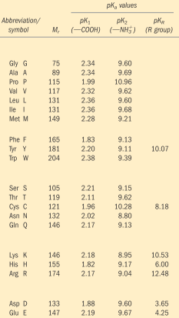

BIRLA INSTITUTE OF TECHNOLOGY AND SCIENCE, PILANI
BIO F215, BIOPHYSICS

SECOND SEMESTER 2015 – 2016
COMPREHENSIVE EXAMINATION (OPEN BOOK)
Full marks: 35 DATE: 13.05.16 DURATION: 1 Hr.
- Answer to the point
- Answer all parts of same question together
- Irrelevant answer may attract penalty
- Steps in each calculation carry marks
1. a) Consider that in a special physiological condition 99.99% of all DNA bases are in enol and imino form. Draw best possible base pair scheme in such condition. [5]
b) The following CD spectra are for three different proteins. Based on this spectral data identify nature of secondary structural unit present on each of these proteins. [MRE is mean residue ellipticity units]. Justify your answer. [5]

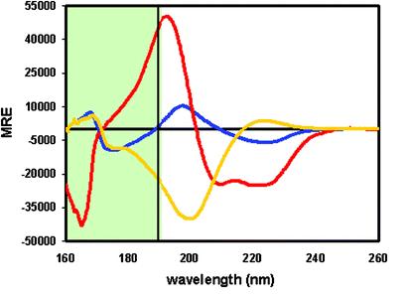

2. a) Identify amino acid side chain which can specifically bind through i) Major groove of GC basepair ii) Minor groove of AT basepair. Pictorially justify your answer. [5]
b) i) Why do you think hydrogen bond and disulphide bond formation could not possibly be the driving forces of protein folding? [3]
ii) With the help of appropriate figure explain the fact that δ torsion angle  always adopts a value near 120 degree. [2]
3. a) State the differences in the Zipper models for polypeptides and polynucleotides (answer in points, the physical reasons behind these differences). [5]
b) How the same concept is translated in the mathematical derivations? [5]
4. How X-rays can be used to determine a structure of biopolymer? (You may answer this question without any mathematical derivation!) [5]

***********************************GOOD LUCK*************************************

